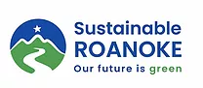

Sustainable Roanoke Recyclables

Sustainable Roanoke volunteers are collecting a varied number of recyclable materials to send to different recycling/reusing/repurposing facilities. Anyone reading this can do the same thing on their own, or get groups of people together and combine efforts.

Important announcement! Due to the large volume of recyclables we receive at our events, we will no longer be collecting cat food & tuna cans and metal in general. Instead, we ask that you take any metal you need to recycle to Gerdau Metal Recycling, located at 2580 Broadway Ave SW, Roanoke, VA 24014. They will give you money for your metal, which you can pocket or ask Gerdau to add to Sustainable Roanoke’s account.

The items we collect for recycling are divided into two large categories, which reflect the physical division we keep during our recycling events: A) More common items and B) Less common items. You will need to pre-sort ALL ITEMS before you get to the event location. But you will be able to access the less common items area directly, whereas in order to access the more common items you will have to check with our volunteers first, so that they can make sure that all your more common items are correctly pre-sorted. There are 2 reasons for this: 1. We receive a large amount of those common items and 2. They are frequently sorted incorrectly.

A) More common items

1. Snack & candy wrappers; straws, lids, & cups; coffee pods First Team Subaru (Love the Earth Program)

You can bring these items to our events or you can take them to Subaru yourself: 6520 Peters Creek Rd, Roanoke, VA 24019 ((540) 566-5609).

Accepted items: There are 3 drop off boxes at First Team Subaru. Make sure to drop your items in the correct boxes:

Box A - Snack Bag, candy wrappers
Box B - Coffee pods
Box C - Straws, cups, lids

Best Practices: Remove all food residue, remove all liquids.

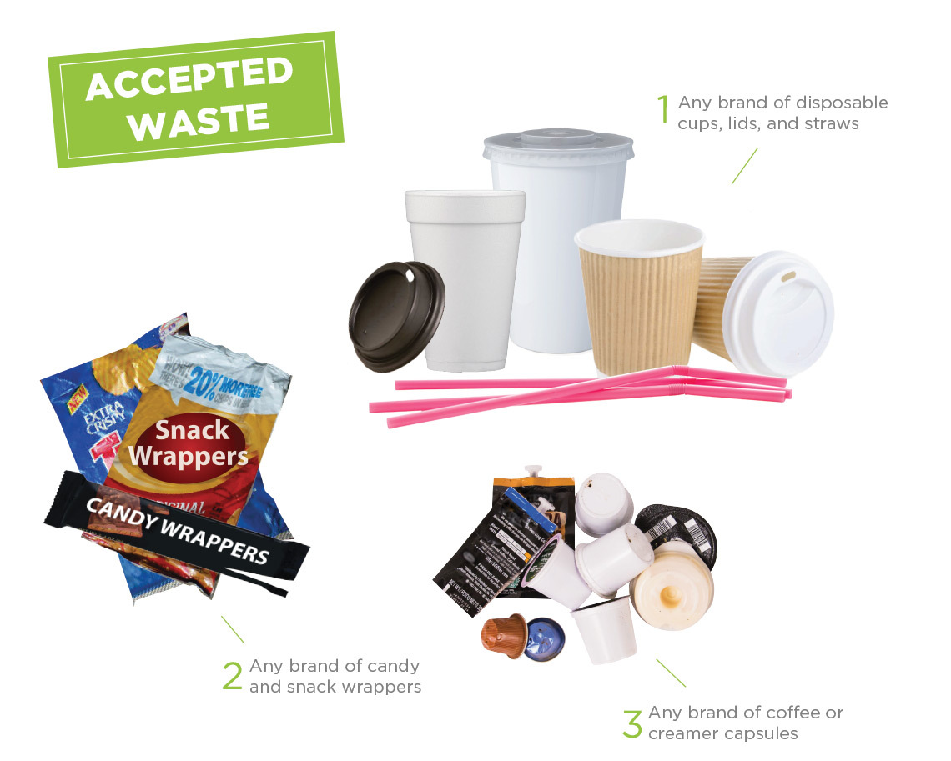

2. #2 Plastic Plastic On Purpose (Staunton, VA)

Accepted items: Any #2 plastic WITHOUT labels, stickers, etc.

Important: The RDS collects #2 plastic as well, but we learned that not all plastic gets recycled. A computer detects certain shapes and sizes but ignores certain others, such as small non-prescription pill bottles. We take them all!

Best practices for recycling: All materials must be clean, dry, and free of product residue, labels, stickers…

3. Plastic film Trex Challenge

The items below are collected on behalf of North Cross School, which participates in the Trex Challenge. If you would like, you could get other schools involved in this challenge, or you can bring your plastic film to us. Whatever you do, DO NOT PUT THESE IN THE TRASH OR IN THE CITY’S RECYCLING BINS!

Check out the video we made explaining what kinds of plastic we collect.

Accepted items:
- Grocery bags
- Bread bags
- Case overwraps
- Dry cleaning bags
- Newspaper sleeves
- Ice bags
- Wood pellet bags
- Ziplock & other re-sealable bags (except the ones made for frozen foods!)
- Produce bags
- Bubble wrap
- Salt bags
- Cereal bags
- Tarps

Required: All materials must be clean, dry and free of food residue

4. #4 Plastic Plastic On Purpose (Staunton, VA)

Accepted items: Any #4 plastic WITHOUT labels, stickers, etc.

Best practices for recycling: All materials must be clean, dry, and free of product residue, labels, stickers…

5. #5 Plastic Plastic On Purpose (Staunton, VA)

Accepted items: Any #5 plastic WITHOUT labels, stickers, etc.

Required: All materials must be clean, dry and free of food residue, labels, stickers…

6. Packing polystyrene foam (Styrofoam) Atlas Molded Products (276) 638-3592 (445 Industrial Park Dr, Ridgeway, VA 24148)

Accepted items: White, CLEAN Styrofoam.

Best practices for recycling (as explained to us by Atlas Molded Products): Remove all dirt, tape, stickers… Make sure it’s clean. DO NOT BREAK UP.

Check out our video to learn the differences between packing and foodservice Styrofoam.

7. Foodservice polystyrene foam (Styrofoam) Dart Container Foodservice Products

Accepted items: Cups, egg cartons, and other Styrofoam used to package & serve food.

Best practices for recycling: Items must be washed clean and dry.

Send to:
DART Container
ATTN: Recycling
60 E. Main Street
Leola, PA 17540

8. Plastic food storage containers TerraCycle

Accepted items: All brands of food storage containers, as long as they are plastic.

9. Kroger flexible plastic packaging TerraCycle

Accepted items: Any Kroger brand flexible plastic packaging, including frozen food bags.

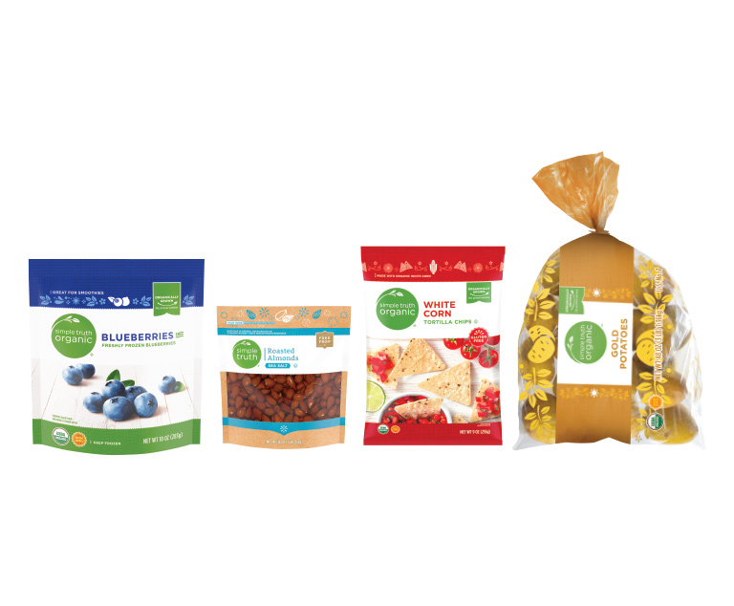
Not accepted: Non-flexible packaging, like the items in the photo below.

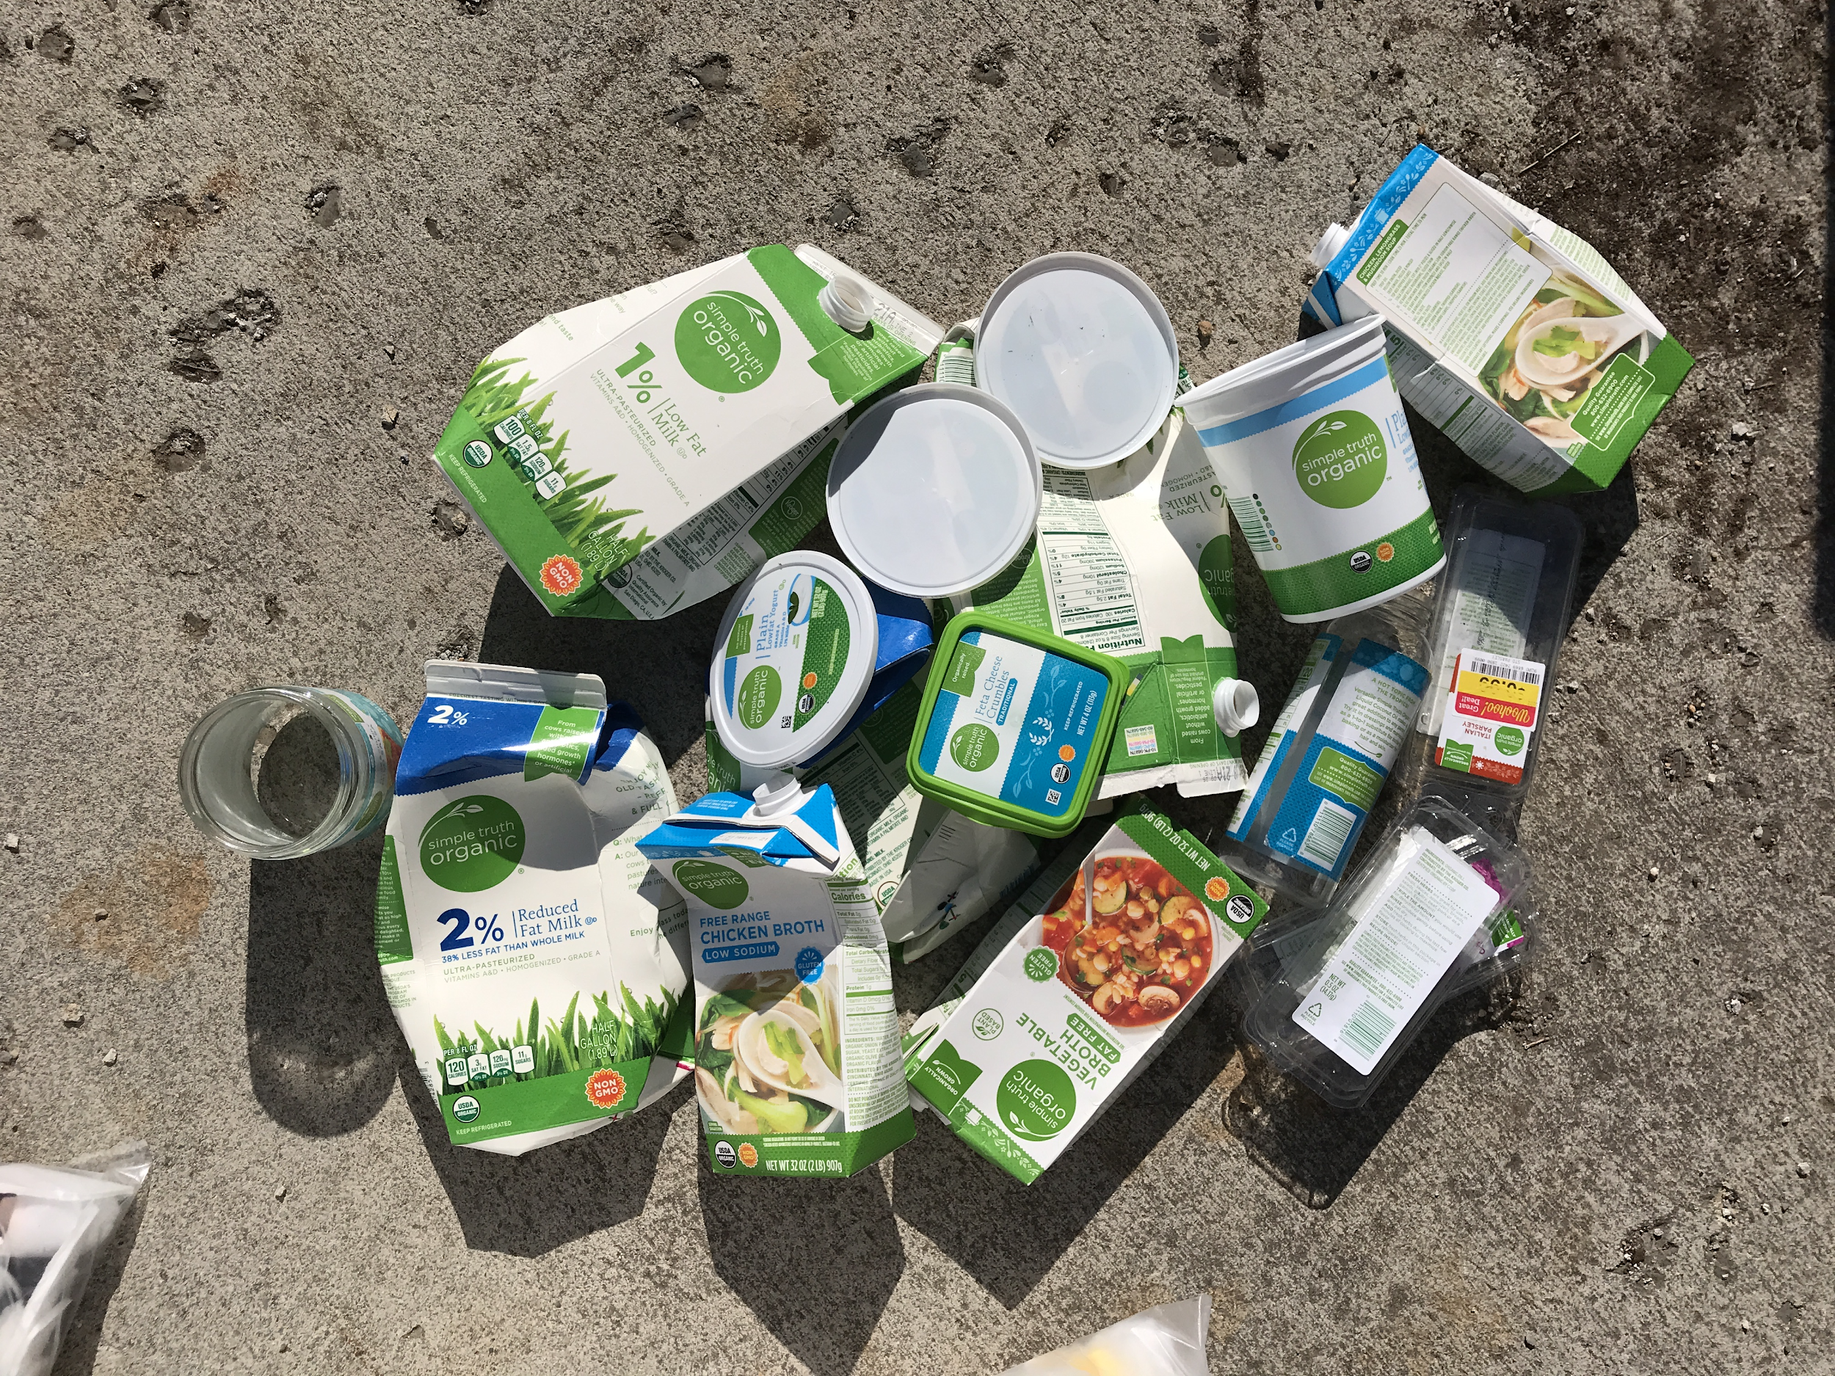

B) Less common items

9. Oral care products TerraCycle (Tom's of Maine Program)

Accepted items: Mouthwash bottles and caps, toothbrushes, deodorant containers and caps, soap packaging, floss containers, and toothpaste tubes and caps.

Not accepted: Electric toothbrushes, battery toothbrushes, and/or their parts.

Best practices for recycling: In order to recycle this waste stream properly, please make sure all excess product has been removed (i.e. leftover toothpaste or floss). Additionally, if you choose to rinse your product, please note that it must be completely dry prior to shipping.
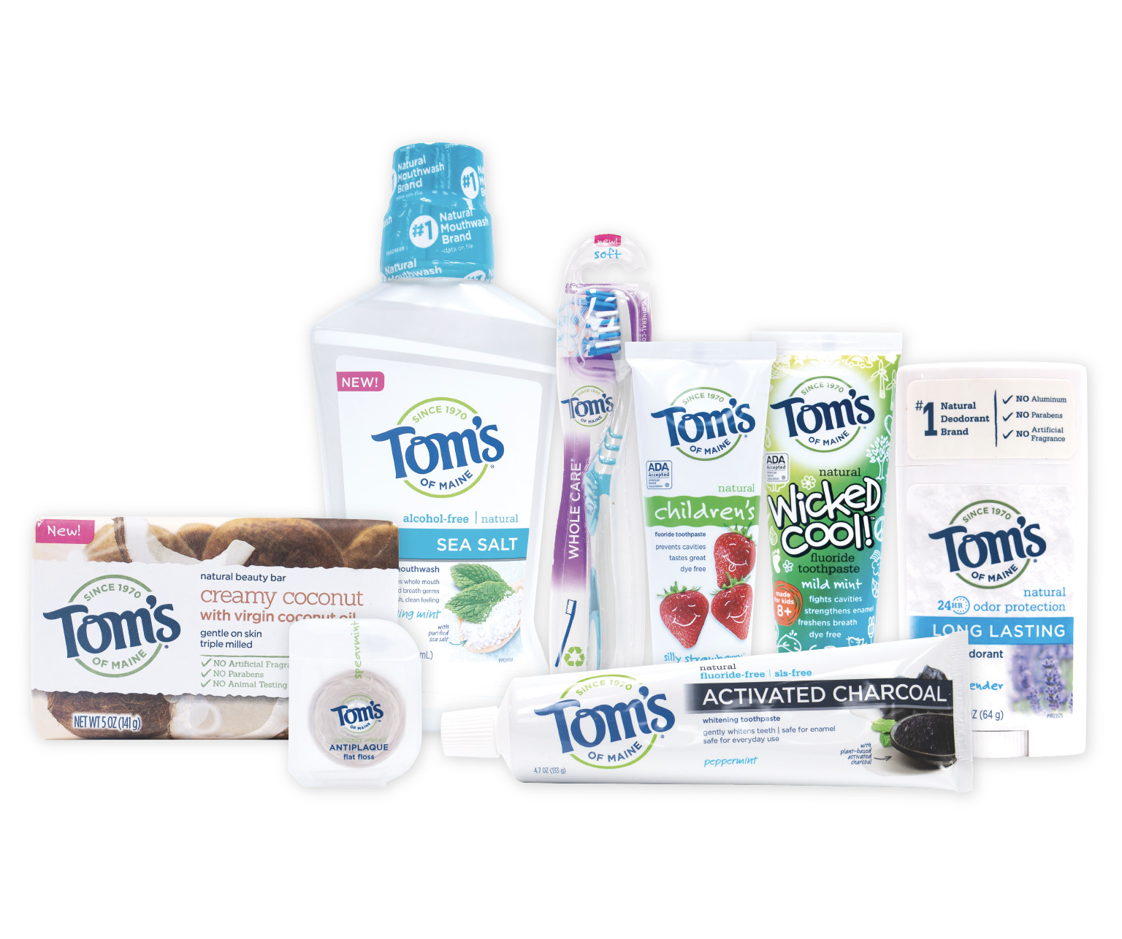

10. Razors TerraCycle (Gillette Program)

Accepted items: All brands of blades and razors (systems and disposable units, and replaceable-blade cartridge units), rigid plastic packaging, and flexible plastic bag packaging.

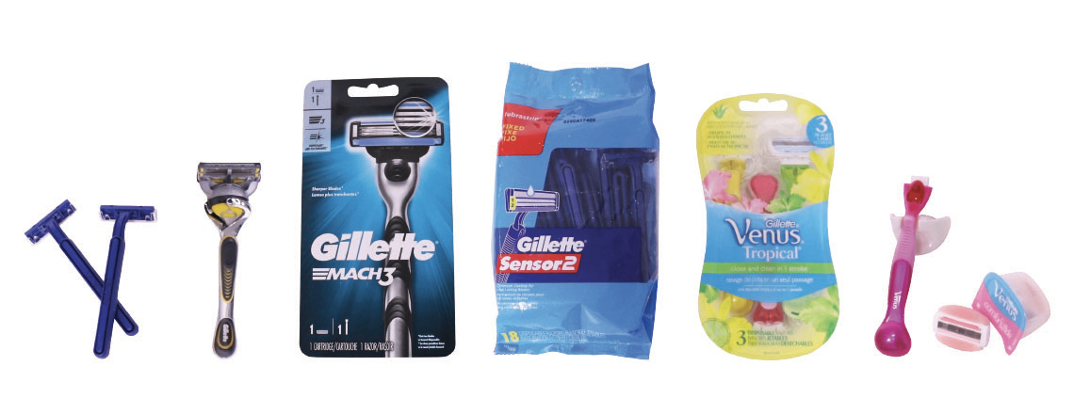

11. Personal care TerraCycle

Accepted items: Hair care packaging such as shampoo caps, conditioner caps, hair gel tubes and caps, hair spray triggers, and hair paste caps. Skin care packaging such as lip balm tubes and caps, soap dispensers and tubes, body wash caps, lotion dispensers and caps. Cosmetics packaging such as lipstick cases, lip gloss tubes, mascara tubes, eyeshadow cases and tubes, bronzer cases, foundation packaging, powder cases, eyeliner cases, eyeliner pencils, concealer tubes, concealer sticks, and lip liner pencils.

Best practices for recycling: In order to recycle this waste stream properly, please make sure all excess/leftover product has been removed. Additionally, if you choose to rinse your product, please note that it must be completely dry prior to shipping.

12. Bausch + Lomb ONE by ONE Recycling Program TerraCycle

Accepted items: Contact lenses and blister packs from all brands.

Important: Do NOT include the cardboard box, which should go into your regular paper recycling.

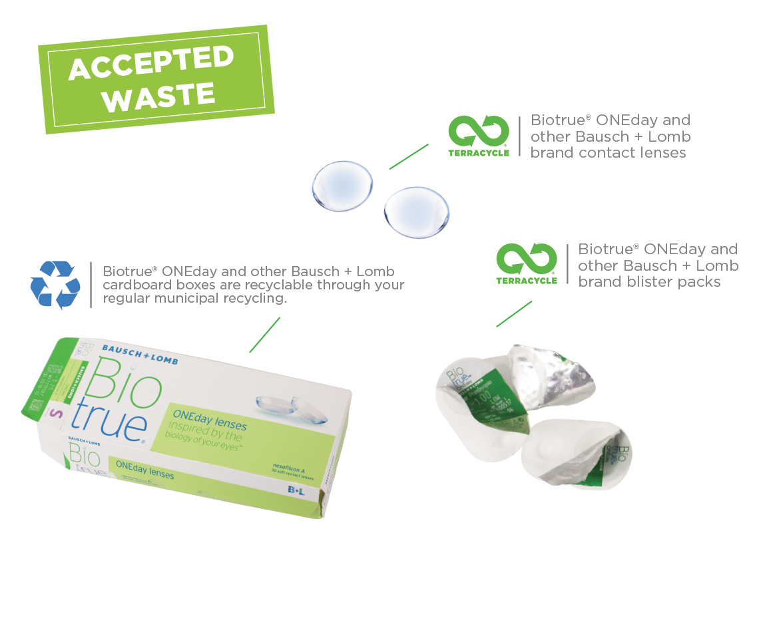

13. Health and nutrition packaging TerraCycle

Accepted items:

- Vitamins, minerals, and supplements packaging: blister packs, tubes, bottles, caps, lids, cans, boxes
- Sexual health and well-being packaging: tubes, bottles, caps, lids, wrappers, cans, boxes
- Cough, cold, flu, sore throat, and nasal care packaging​: blister packs, tubes, bottles, spray bottles, caps, lids
- Infant formula and child nutrition packaging: tubs, bottles, caps, lids, cans, boxes
- Personal care and foot care packaging: tubes, bottles, caps, lids, plastic packaging

Important: This program does NOT accept any prescription bottles for recycling.

Best practices for recycling:

- Ensure all excess product liquids, such as medicines and topicals, have been removed.
- If you choose to rinse your products, note they must be completely dry prior to shipping.

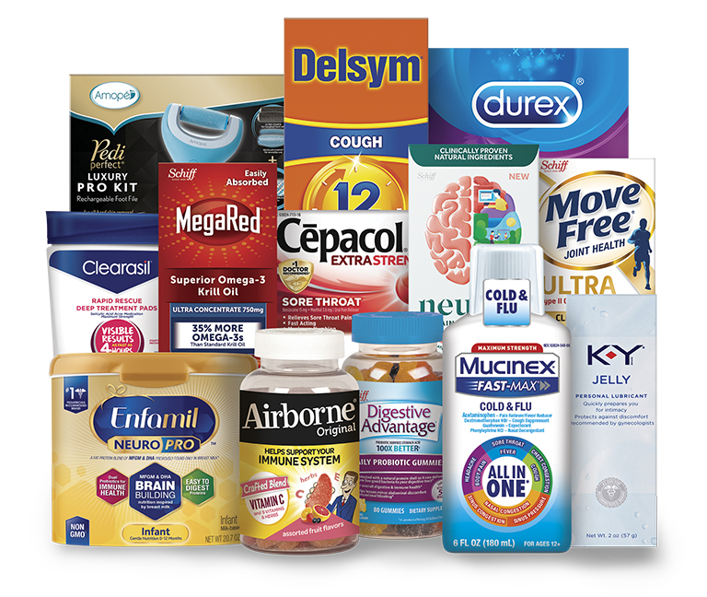

14. Personal Protective Equipment TerraCycle

Accepted items: PPE (disposable face masks, visors, disposable gloves, ear plugs, beard snoods, hair nets, safety glasses or disposable garments etc.).

Not accepted: Medical waste, such as material contaminated with blood or bodily fluids or wastes from healthcare facilities, hospitals, home care, doctors' offices, dental offices, blood banks, veterinary clinics, research laboratories, etc. We also cannot accept fabric, homemade or paper masks!

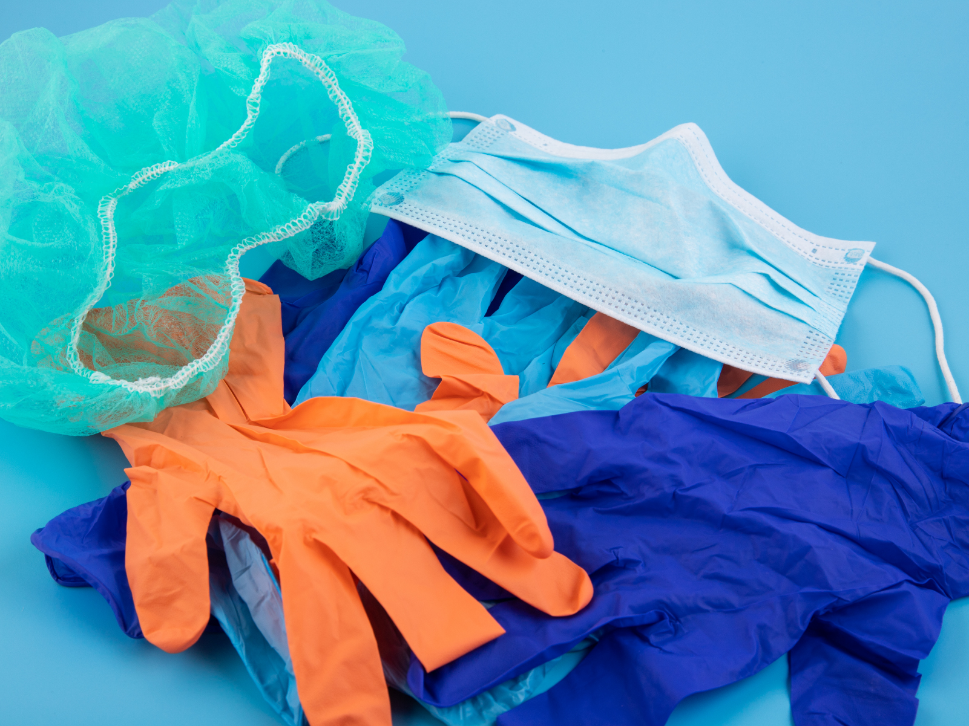

What happens to the collected PPE? Check out the TerraCycle website to learn how the different materials are processed.

15. Sneakers Got Sneakers

Accepted items: Gently used sneakers.

For detailed guidelines, click here. Sneakers in good condition will be donated to people in need around the world. Unwearable footwear will be turned into rubber mats and other athletic surfaces.

This program is a fundraiser for Sustainable Roanoke and North Cross School.

16. Teva Sandals Teva

Accepted items: Any Teva sandals.

Best practices for recycling: Make sure they are clean and dry!

Important: At Sustainable Roanoke we thought it makes sense to gather many of them to minimize the shipping carbon footprint but, if you have a bunch of them, you can send them to Teva yourself - check out this link to learn how to do it.

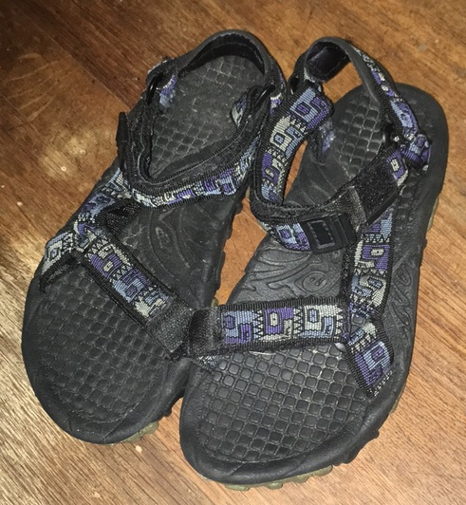

17. Guitar strings D’Addario

We will bring the strings to Fret Mill Music Co., located at 19 Salem Ave SE, Roanoke, VA 24011, USA in downtown Roanoke.

18. Bread clips Danielle Cares for Chairs

Danielle Cares for Chairs is a non-profit that recycles the tags and uses the funds to provide wheelchairs to people in need.

19. Brita products TerraCycle/Brita

Accepted items: All Brita products seen on the photo. Attention: Only Brita brand!

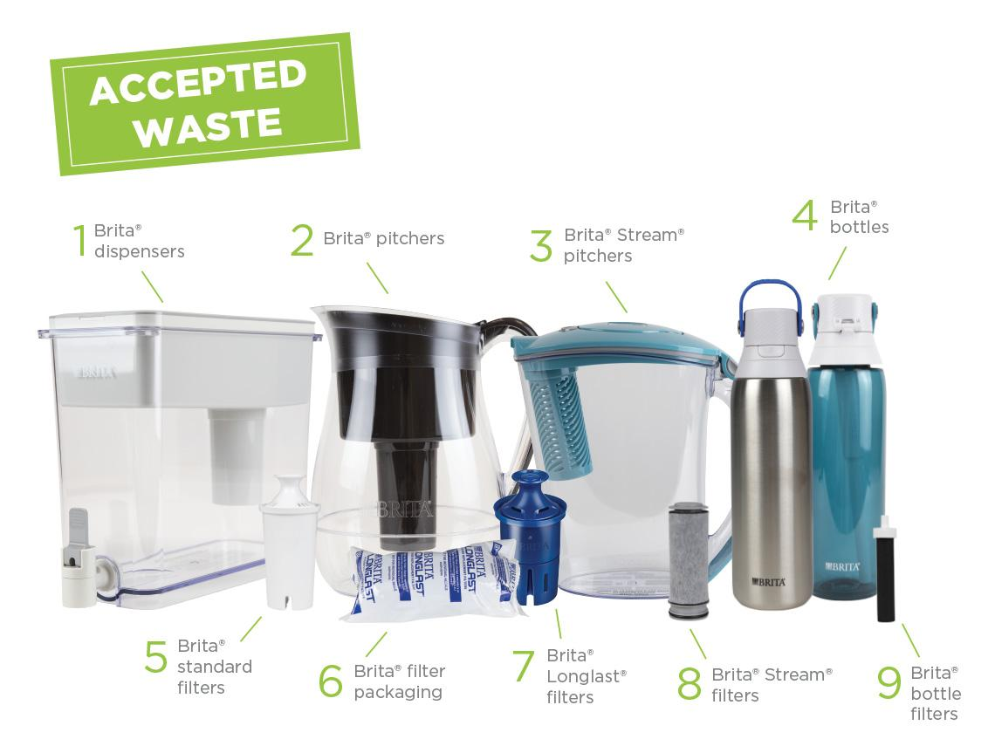

Best practices for recycling: Items must be THOROUGHLY dry.

20. Febreze Air Care Products TerraCycle

Accepted items: All brands of air freshener cartridges, plugs, trigger heads, and plastic and film packaging.

Not accepted: They do not accept plastic bottles, because they say these can be recycled through most municipal programs.

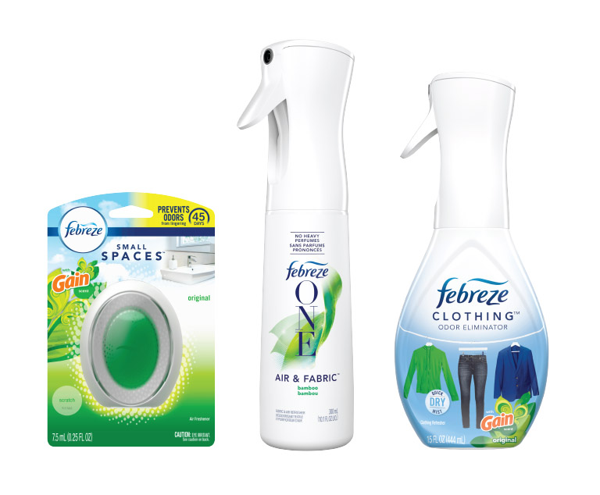

Best practices for recycling: You don’t need to clean the packaging before sending it to TerraCycle, but please remove as much of the remaining product as possible.

21. Phone cases & pop sockets TerraCycle

Accepted items: All PopSockets products and packaging, and phone cases from any brand.

In case you, like us, don’t know what a pop socket is, check out the picture below!

22. Tennis balls Recycle Balls or donate to local schools to be used as floor protection in chairs

Best practices for recycling: Balls must be clean and dry.

23. Stationery Recycling Program TerraCycle

Accepted items: All brands of empty writing instruments, glue sticks, watercolor dispensers, paint sets, and flexible packaging.

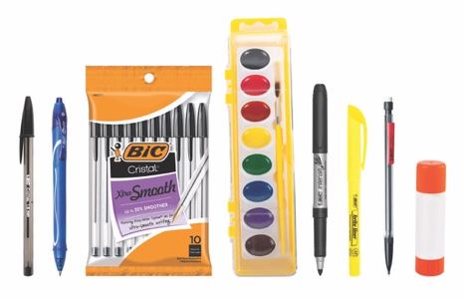

24. Wrapped plastic flatware and condiment packages RAM House

Accepted items: Plastic flatware still in its original plastic wrap (such as the type that is given with takeout orders) and small condiment packages.

What happens to these items? A volunteer will take them to RAM House to distribute among people who need them. Although they will not get recycled, at least they will have served a purpose!

